

Vellore - 632 014, Tamil Nadu, India

**SCHOOL OF INFORMATION TECHNOLOGY AND ENGINEERING**

**B.Tech (IT)**

**FARMATE**

**(12BIT0095)GAJENDRAN**

**(12BIT0021)CHRIS MACMAN**

**(12BIT0072)SANTHOSH KUMAR**

**(12BIT0205)KATHIR RAJ H**

**Project Report**

**of**

**ITE309-Web Technologies PBL Course**

**Fall 2014-15**



Vellore - 632 014, Tamil Nadu, India

**SCHOOL OF INFORMATION TECHNOLOGY AND ENGINEERING**

**B.Tech (IT)**

**Farmate**

**(12BIT0095)GAJENDRAN**

**(12BIT0021)CHRIS MACMAN**

**(12BIT0072)SANTHOSH KUMAR**

**(12BIT0205)KATHIR RAJ H**

**Project Report**

**of**

**ITE309-Web Technologies PBL Course**

**Fall 2014-15**

**Submitted to Signature:**

**Faculty : Prof.B.R.Kavitha Date :**

**Abstract**

In India most of the families are depend on the Agriculture, but the profit which farmer gains is very low. While selling his product to the market with the help of the middleman, the middleman yields more profit compared to the farmer. The profit which gained by the farmer is not worth for his hard work. The only solution to avoid this problem is to drop the middleman and makes the farmer to sell his product directly to the market. In order to achieve this solution we designed a webpage to makes the farmer to sell his product directly to the market. In this webpage farmer will get into his account using his unique id. His account contains different option like selling, loan, buying accessories. Here farmer can sell his product directly to the market dealer with fixed MSP also farmer can increase or decrease bedding amount under sell option. He can take loan from the bank for his farming purpose under loan option. He can buy accessories from the accessory dealer under buy option. The farmer page is very user friendly with pictorial option. The website also contains market dealer authentication and accessory dealer authentication. In market dealer the dealer can buy products from the farmer based on the price offered by the farmer, also he can sell his product to the others which is categorized based on crops type. In accessory dealer page the dealer receives the request from the farmer as number of accessories farmer needs, even though the dealer can increase or decrease the accessory rate, offer, availability of the accessories in his page which will display in the farmer page. With the help of this website the farmer will yields more money also reduce the work of the farmer

**TABLE OF CONTENTS**

|  |  |  |
| --- | --- | --- |
| **S.NO.** | **DESCRIPTION** | **PAGE NO.** |
| 1. | **LIST OF TABLES** | iii |
| 2. | **LIST OF FIGURES** | iv |
| 3. | **LIST OF SYMBOLS, ABBREVIATIONS AND NOMENCLATURE** | v |
| 4. | **INTRODUCTION**  4.1 Existing And Proposed System  4.2 Intuition To Do This Project |  |
| 5. | **REQUIREMENTS**  5.1 Tools And Technologies Used |  |
| 6. | **SYSTEM ARCHITECTURE**  6.1 Er Diagram  6.2 Relational Schema  6.3 Use Case Diagram  6.4 Activity Diagram |  |
| 7. | **MODULES**  7.1 Student Entity  7.2 Block Entity  7.3 Room Entity |  |
| 8. | **TESTING**  8.1 Black Box Testing  8.2 White Box Testing  8.3 Unit Testing  8.4 Integration Testing |  |
| 9. | **SCREENSHOTS** | 21-28 |
| 10. | **CONCLUSION AND FUTURE ENHANCEMENTS** | 29 |
| 11. | **APPENDICES** | 30-33 |
| 12. | **REFERENCES** | 34 |

**LIST OF TABLES**

|  |  |  |  |
| --- | --- | --- | --- |
| **S.NO.** | **DESCRIPTION** | **TABLE NO.** | **PAGE NO.** |
| 1. | Student Entity | 4.1 | 12 |
| 2. | Block Entity | 4.2 | 13 |
| 3. | Room Entity | 4.3 | 13 |
| 4. | Testing Methods | 5.1 | 20 |

**LIST OF FIGURES**

|  |  |  |  |
| --- | --- | --- | --- |
| **S.NO.** | **DESCRIPTION** | **FIGURE NO.** | **PAGE NO.** |
| 1. | xyz | 3.1 | 7 |
| 2. | xyz | 3.2 | 8 |
| 3. | xyz | 3.3 | 9 |

.

**LIST OF SYMBOLS, ABBREVIATIONS AND NOMENCLATURE**

|  |  |
| --- | --- |
| **ABBREVIATIONS** | **FULL FORM** |
| ER | Entity Relation |
| PHP | Pre Processor Hyper Text |
| Spec. | Specification |
| CSS | Cascading Style Sheet |
| MSP | Minimum support price |

**1. INTRODUCTION**

Agriculture is the backbone of our country, nearly three-quarters of India’s families depend on farming. The farmer is an important part of agriculture. Agriculture depends on him. It is the toil of the farmer which brings prosperity in the country. His contribution is invaluable. He is an important member of our society. In other words, it is the land of farmers. The life of an Indian farmer is very hard. Since the Indian farmer is generally uneducated, he is unaware of technological advancements and scientific development. He is unfamiliar with the latest technology and equipment developed in the field of agriculture. He makes use of generation-old methods and techniques in farming. He is ignorant of the program and policies of government which are meant to bring relief and comfort in his life. Due to his ignorance he fails to reap the benefits of those program and policies. His ignorance becomes the cause of his victimization either at the hands of money-lenders or Nature. This project helps the farmer to get the maximum profit and also it reduce the work tension of the farmer. It helps the farmer to do his job easily.

* 1. **EXISTING AND PROPOSED SYSTEM**

The location of the farmer is village. After cultivating his crops from his place he is not able travel to the urban area even he won’t show interest on that. Normally farmer won’t go to market area and make a deal with the market dealer, he usually things that it is waste of time and risk, so farmer sell his product to the market with the help of a middle man. He don’t have time and such knowledge to sell his product directly to the market.

In village farmer sell his product to the middle man based on his satisfied profit. Even the middle man will ask his product less than the MSP, by seeing the situation he has no way rather than selling his product at last he will sell his product with lower price. The profit which farmer yields is very low due to his poverty and illiteracy. The main reason for this low profit is middleman. Usually farmer sells their products to market with the help of a middleman. The middleman charges high interests, buy goods at rats much lower than the MSP set by the government and he exploit the farmers.

* 1. **INTUITION TO DO THIS PROJECT**

Since the Indian farmer is generally uneducated, he is unaware of technological advancements and scientific development. He is unfamiliar with the latest technology and equipments developed in the field of agriculture. He makes use of generation-old methods and techniques in farming. He is ignorant of the programmes and policies of government which are meant to bring relief and comfort in his life. Due to his ignorance he fails to reap the benefits of those programmes and policies. His ignorance becomes the cause of his victimization either at the hands of money-lenders or Nature.

Even though government offered many schemes like kissan call centre, kissan credit cards, aam aadmi bima yojana ,.. It did not reached the farmers properly. 60% of the farmers are selling their crops at less than Minimum Support Price. Farmers do not have information about basic facilities such as MSP, crop insurance, helpline numbers for farmers. To overcome these kind of problems we need to drop the middleman and makes the farmer to sell his own product directly to the market dealer. The main aim is to facilitate a farmer’s trade and ensure that he benefits from all the schemes set by the government for him. These are reasons for intuition to do this project. For this we develop a website with pictorial interface for the better understand ability of even illiterate farmers.

**2.** **REQUIREMENTS**

Here we are going to discuss about all the requirements related to the project The tools and technologies that are involved are the most important aspects of any project and it is very important to deal with them in the best possible way.

**2.1 TOOLS AND TECHNOLOGIES USED**

**SOFTWARE**

**Sublime Text 3 :** to write the web designing code.

**Notepadd++ :** to write the web designing code.

**Crome :** to run the html code.

**XAMPP :** used as a local host and also used to run the php code and manipulate the database

**LANGUAGE**

**HTML** (Hyper Text Markup Language): To create the web pages.

**CSS**(Cascading Style Sheet) : To style the web pages.

**Javascript**: To create dynamic and interactive web pages and for form validation.

**PHP** (Hypertext Pre Processor): For server side scripting.

**Mysql** : To perform operations related to database.

**System Architecture**

Detailed Design of the modules

DFD, ER diagrams or whichever is applicable

**Modules**

* Form
* Authentication page

**Testing**

|  |  |  |  |
| --- | --- | --- | --- |
| **TESTID** | **SAMPLE TEST CASES** | **EXPECTED OUTPUT** | **RESULT** |
| Farmate-01. | In farmer login farmer username and password were entered. | If username and password matches, farmer page is displayed else redirected to the same login page. | Passed |
| Farmate-02. | In market dealer login dealer username and password were entered. | If username and password matches, market dealer page is displayed else redirected to the same login page. | Passed |
| Farmate-03. | In accessory dealer login dealer username and password were entered. | If username and password matches, accessory dealer page is displayed else redirected to the same login page. | Passed |
| Farmate-04. | In farmer login the MSP value is entered very less instead of fixed MSP | Display popup message else redirected to the successful page | Passed |

**Screenshots**

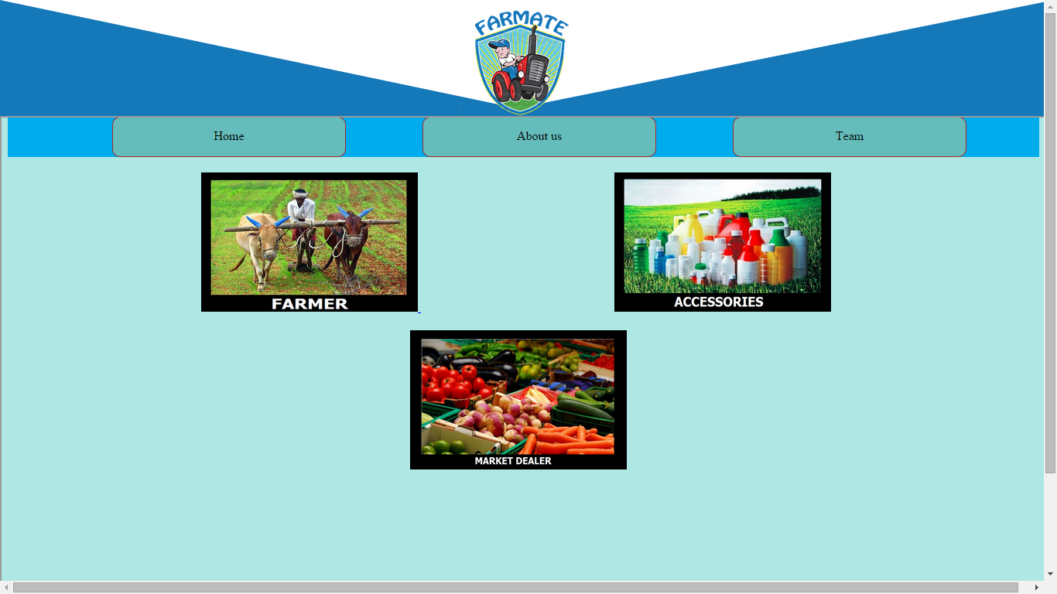

**Conclusion and further Enhancements**

Thus, a farmer is the backbone of agriculture. We need to be sensitive towards him. The governmental and non-governmental organizations should come forward and make him aware of the latest technologies, programmes and policies. His prosperity means prosperity of the nation.

**References**

* W3schools.com
* Php video tutorials of bucky
* Tutorialpoints.com
* Class notes of prof.kavitha.B.R